COS30031 Games Programming

Learning Summary Report

Khang Trinh - 102118468

Self-Assessment Details

The following checklists provide an overview of my self-assessment for this unit.

|  |  |  |  |  |  |
| --- | --- | --- | --- | --- | --- |
|  | Pass (P) | Credit (C) | Distinction (D) | High Distinction (Low HD) | (High HD) | |
| Self-Assessment (please tick) | x |  |  |  |  |

*Self-assessment Statement*

|  |  |
| --- | --- |
|  | Included? (tick) |
| Learning Summary Report | x |
| Time-boxed Demonstration Activity (Lab Test) in Doubtfire |  |
| Complete Pass (“core”) task work, approved in Doubtfire |  |

*Minimum Pass Checklist*

|  |  |
| --- | --- |
|  | Included? (tick) |
| Additional non-core task work (or equivalent) in a private repository and accessible to staff account. |  |
| Spike Extension Report (for spike extensions) in Doubtfire |  |
| Custom Project plan (for D and/or low HD), and/or High HD Research Plan document in Doubtfire (optional) |  |

*Credit Checklist, in addition to Pass Checklist*

|  |  |
| --- | --- |
|  | Included? (tick) |
| Custom Project Distinction Plan document, approved in Doubtfire |  |
| All associated work (code, data etc.) available to staff (private repository), for non-trivial custom program(s) of own design |  |
| Custom Project “D” level documents in Doubtfire, to document the program(s) (structure chart etc) including links to repository areas |  |

*Distinction Checklist, in addition to Credit Checklist*

|  |  |
| --- | --- |
|  | Included? (tick) |
| Custom Project “HD” level documents in Doubtfire, to document the program(s) (structure chart etc) including links to repository areas |  |

*Low High Distinction Checklist, in addition to Distinction Checklist*

|  |  |
| --- | --- |
|  | Included? (tick) |
| High Distinction Plan document, approved in Doubtfire |  |
| High Distinction Report document, in Doubtfire, which includes links to repository assets |  |
| All associated work (code, data etc.) available to staff (private repository) for your research work |  |

*High High Distinction (Research) Checklist, in addition to D/Low HD Checklist*

# Introduction

This report summarises what I learnt in COS30031 Games Programming. It includes a self-assessment against the criteria described in the unit outline, a justification of the pieces included, details of the coverage of the unit’s intended learning outcomes, and a reflection on my learning.

# Overview of Pieces Included

This section outlines the pieces that I have included in my portfolio…

*Describe the pieces you have included in your portfolio.*

*This should contain a* ***list*** *of all the pieces, along with a short statement of* ***why*** *each piece was included.*

* In this unit, I’ve learned about data structures and programming patterns and optimization skills - ways to optimize my program. All tasks included are to demonstrate this.
* I’ve also included 2 pieces from my side project, one is a discord bot (created in Js) to demonstrate my understanding of task 13 – Command pattern, the other is a health script for components (created in C#) to demonstrate my understanding of task 21 – Messaging system. Since I was not able to complete these tasks on time, these pieces should hopefully be enough to demonstrate my already understanding of the concepts.

# Coverage of the Intended Learning Outcomes

This section outlines how the pieces I have included demonstrate the depth of my understanding in relation to each of the unit’s intended learning outcomes.

## ILO 1: Design

*Discuss game engine components including architectures of components, selection of components for a particular game specification, the role and purpose of specific game engine components, and the relationship of components with underlying technologies.*

* All the tasks included demonstrate my understanding of this ILO on a basic level, as I always list out the steps required to implement a game spec, and each step is always implementing a component of some kind.

## ILO 2: Implementation

*Create games that utilise and demonstrate game engine component functionality, including the implementation of components that encapsulate specific low-level APIs.*

* This was demonstrated in most of the tasks, most notably in the SDL related tasks (17, 18, 24)

## ILO 3: Performance

*Identify performance bottlenecks by using profiling techniques and tools, and applying optimisation strategies to improve performance.*

* Task 7 shows my best understanding of this ILO since it shows how I can use the tools provided in Visual Studio to improve code performance. The SDL related tasks also show this as they also include my discussion in why doing things in certain ways are necessary to maintain good performance.

## ILO 4: Maintenance

*Explain and illustrate the role of data structures and patterns in game programming, and rationalise the selection of these for the development of a specified game scenario.*

* Task 8, 11, 13, and 21 are tasks related to applying software patterns in the context of games, which make them strong examples to show my understanding of Maintenance

# Reflection

## The most important things I leant:

The name of the patterns and how I’ve already learned these, I just didn’t know what they were called and how beneficial they are

## The things that helped me most were:

Tutor, cpp reference, Stack Overflow

## I found the following topics particularly challenging:

Graphs, Engine vs Framework

## I found the following topics particularly interesting:

SDL related tasks

## I feel I learnt these topics, concepts, and/or tools really well:

Collisions, Messaging, Graphs, Data structures

## I still need to work on the following areas:

Task specific:

Messaging system: I still don’t have a good solution for dependency issues between the container class containing the references of the receivers while the receiver require the container class to subscribe themselves

General:

Commit messages: I’ve tried

## My progress in this unit was …:

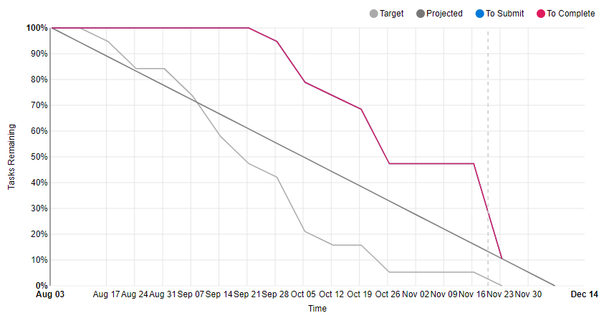

## This unit will help me in the future:

My upcoming capstone for programming degree.

## If I did this unit again I would do the following things differently:

I had a capstone unit for my games degree, so I pretty much left this unit no time for completion. If I were to do this unit again, I’d definitely not do it alongside a capstone unit, or if I did, include only these 2 in the same semester and no other units.

## Other…:

# Conclusion

In summary, I believe that I have clearly demonstrate that my portfolio is sufficient to be awarded a …. grade.

It’d be a fair conclusion to say what I’ve submitted here won’t be enough to even achieve a pass, but I hope to show with my other work that I’ve grasped the concepts of these topics, I just didn’t have time to complete them to this unit’s standards.